Order Of Service

Singing: Psalm 30—CW page 76

Reading: Psalm 85

Opening Hymn: TLH 317

Reading: II Thess.1:1-12

Request Hymn: CW Supplement 760

Reading:Luke 1:57-66

Sermon Hymn: TLH 318

Sermon Text: Acts 2:37-42

Repent

Prayer

The Apostles’ Creed, TLH page 12

Holy Communion

The Lord's Prayer

The Blessing

Closing Hymn: TLH 326

************

Bible Study: Lambs: Undersea Garden
Sheep: Deut 8:1-20
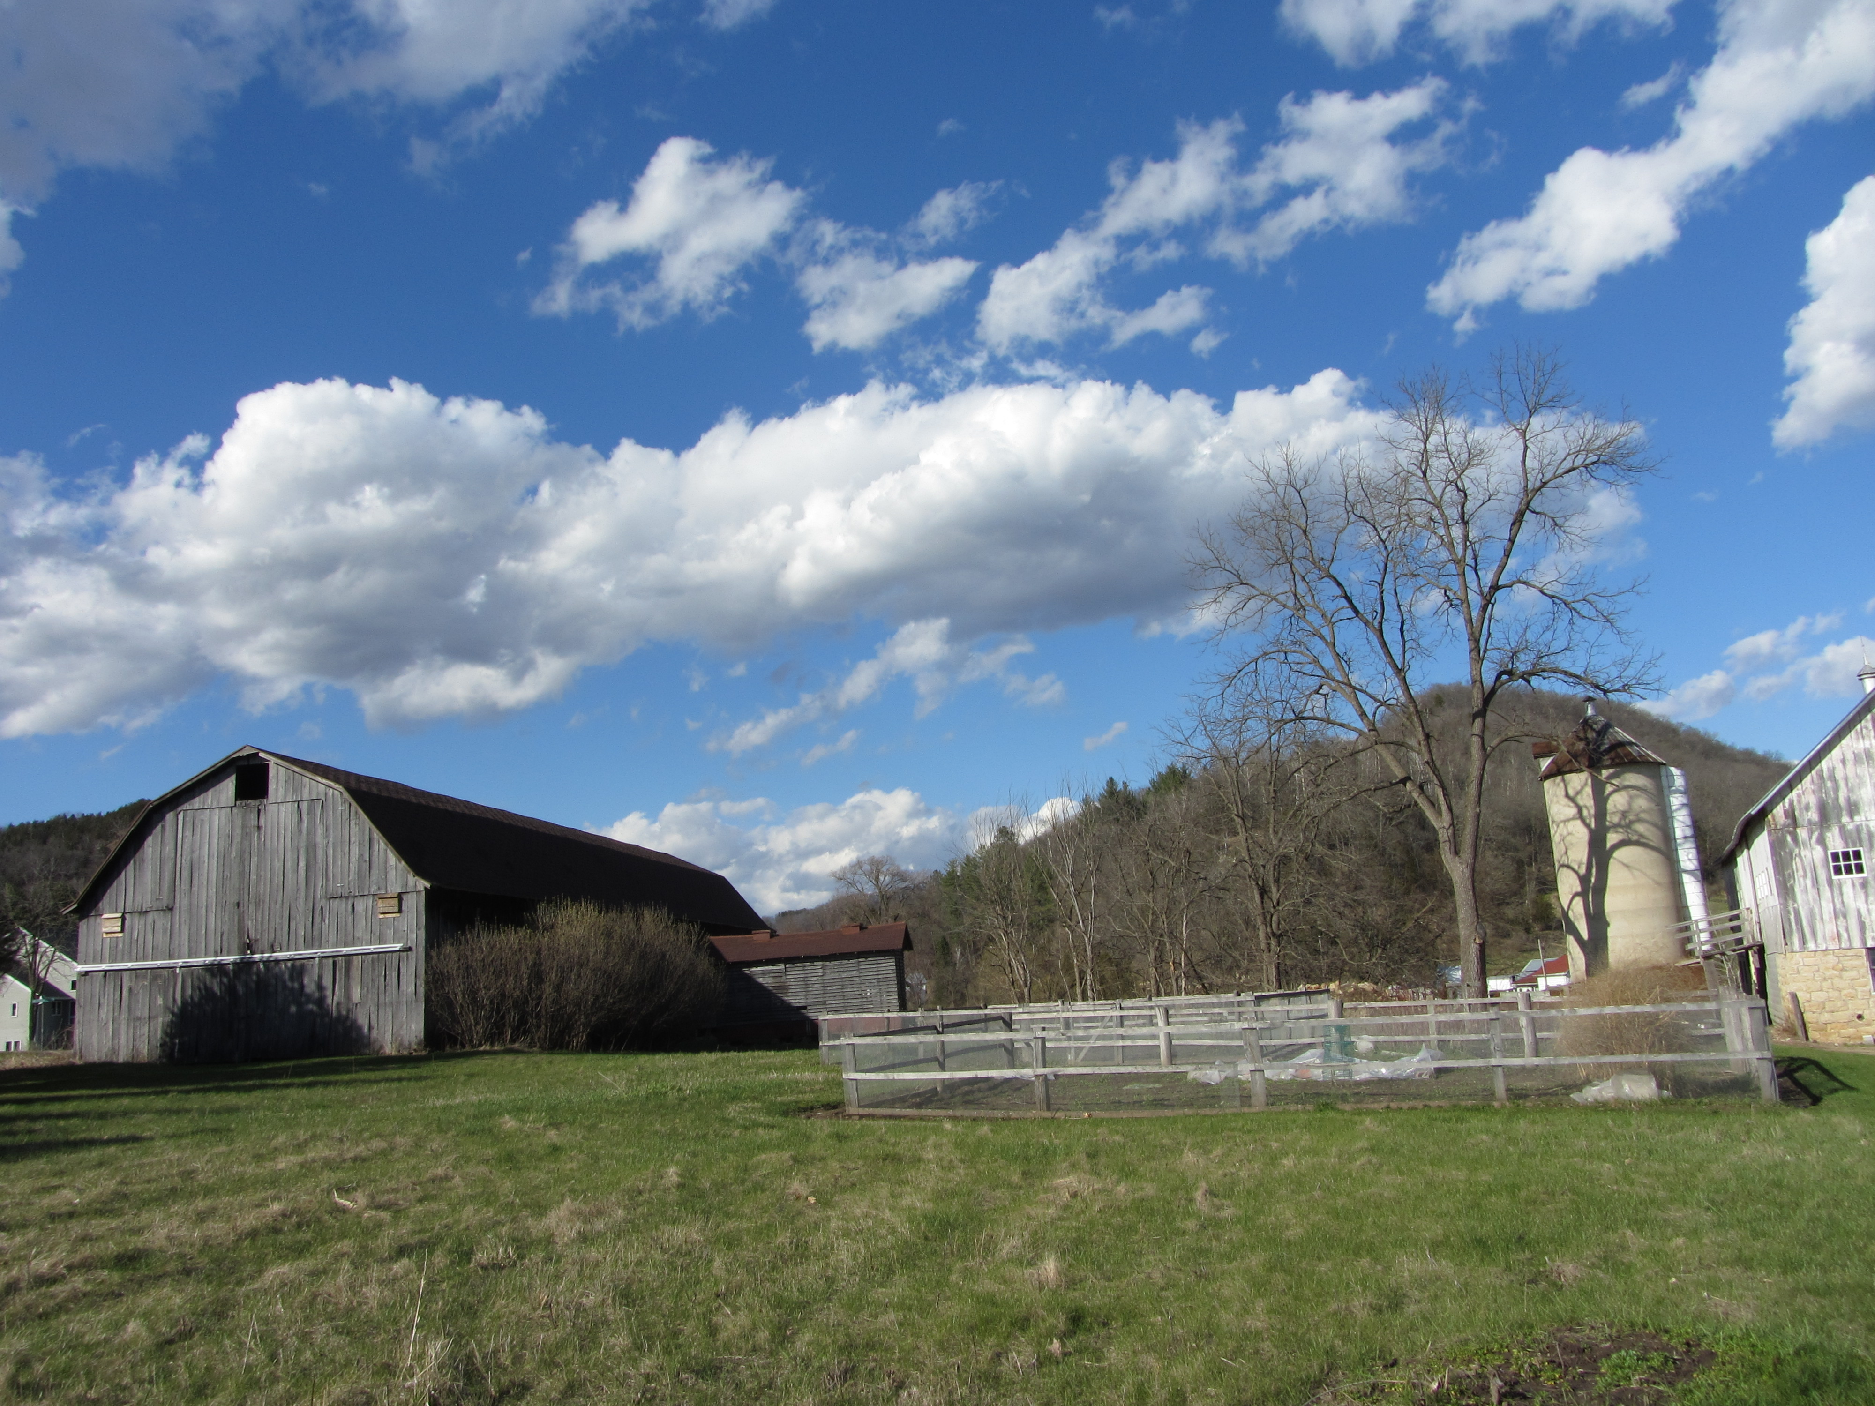

Water
Of
Life

21 January 2024

W A T E R O F L I F E

Independent Christian Church—Conservative Lutheran Doctrine

Worship Service: 9:30 a.m.

Larry Cooper, Pastor E-Mail address:
lcooper@wateroflife.cc
Web Site:
www.wateroflife.cc

* * * * * * * * * * * * * * * * * * * * * * * * * * *

Sermon Text: Acts 2:37-42

Repent

* * * * * * * * * * * * * * * * * * * * * * * * * * *

37 Now when they heard this, they were pricked in their heart, and said unto Peter and to the rest of the apostles, Men and brethren, what shall we do?
38 Then Peter said unto them, Repent, and be baptized every one of you in the name of Jesus Christ for the remission of sins, and ye shall receive the gift of the Holy Ghost.
39 For the promise is unto you, and to your children, and to all that are afar off, even as many as the Lord our God shall call.
40 And with many other words did he testify and exhort, saying, Save yourselves from this untoward generation.
41 Then they that gladly received his word were baptized: and the same day there were added unto them about three thousand souls.
42 And they continued stedfastly in the apostles' doctrine and fellowship, and in breaking of bread, and in prayers.

